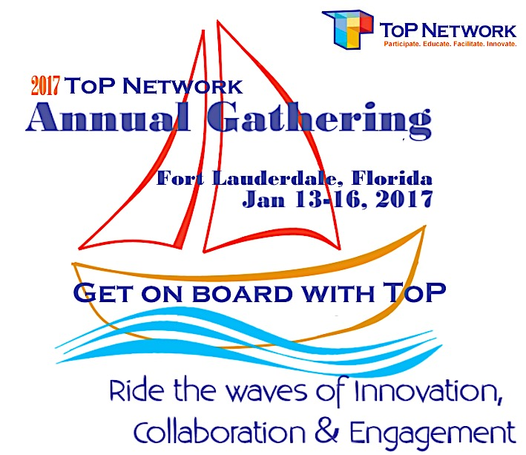

ToP Network Annual Gathering 2017
Get on Board with ToP
Call for Sessions
The 2017 ToP Network Annual Gathering will be held January 13-16 2017 starting at 1:00 pm on Friday and ending at noon on Monday. The Gathering will be located at the Sheraton Suites Fort Lauderdale at Cedar Creek, Florida. The Gathering relies on the talents of ToP Network colleagues to create and facilitate highly informing and interactive sessions.

All are invited to submit preliminary proposals for Gathering sessions. All ideas are welcome; however, we encourage proposals that fall within the Gathering theme or the following topics:

Streams Lead to the Ocean: All About ToP Methods
The foundational ToP Methods can be used in a limitless number of ways. When are the tried and true methods best implemented, as we know them? What are ways you’ve customized methods for special purposes? What is the theory behind the methods? How do we update our language about brain science? How do we grow ToP course offerings and improve marketing? What do we need to do to ensure excellent ToP trainings, quality trainers and a delivery system that sustains them?

Tidal Force of Change: Engaging Communities
How do we best use ToP methods to bring about productive change in communities and organizations? How do we energize the engagement of stakeholders? What community projects have you been facilitating? What are those global conversations and our role as facilitators? What is our role in deciding what kind of change is needed in communities and organizations? What is collective impact and how do we connect CI and ToP to achieve social change? How do we use ToP methods to facilitate conversations about critical issues – e.g. climate action, race relations, and restorative justice?

Riding the Wave: Innovations in Facilitation
What are our learning’s about ToP Methods, complimentary methods, emerging schools of thought, new technologies and interesting new approaches you are exploring? What are ways to evaluate the success of your facilitations? Why should I become a Certified ToP facilitator? How do we engage people with different learning styles in our facilitations? How do we involve people who have limited written communication capability? How do we engage and include youth with ToP facilitation?

Options for length of session:
Best for:
A. 1 hour: Presentations, awareness raising and demonstrations
B. 1 ½ hours: Interactive workshops
B. 2 hours: Engaged exploration of a topic, discovery and planning

Following your submittal:
We’ll follow-up with you with any questions or suggestions and confirm your session. We’ll ask for a more complete session description, your presenter bios, and material/AV requirements at that time.

Dive into your resources. Review your facilitations and training experiences. Share your skill and expertise at the Gathering. Help us offer meaningful and interactive sessions.
ToP Network Annual Gathering 2017
Preliminary Proposals
Due Oct. 21st
Get on Board with ToP - Session Proposal

(Submission instruction below)
Proposed Session Title:

Targeting which theme/topic?  Check applicable theme |  | Streams Lead to the Ocean: All About ToP Methods
 |  | Tidal Force of Change: Engaging Communities
 |  | Riding the Wave: Innovations in Facilitation
Rational Aim:
What you want the group to know, learn or decide by the end of the session? It may include a product, outcome or result.
Experiential Aim:
Describes how a group will be different by the end of the session? It could include things like mood, motivation or state of being.
Brief Session Description:

Presenters

Session Length
Indicate 1 hr., 1 1/2 hrs. 2 hrs.
Submitted by:

Contact Info:

Submission instructions: Save your proposal to your computer (add your name to the file name).
Preliminary Proposals
Due Oct. 21st
Go to: www.top-network.org or http://top.memberclicks.net. Under Quick Links, click on 2017 Gathering Proposal and upload your file.

Questions? email: memberhelp@top-network.org

